

SERVERS INFRASTRUCTURE

App03 & app04

Document version 2.02 – Octobre 2016 (.en version)

General concepts & server purpose

This document lists the strategic choices that we made when setting up the servers for the Mobminder App.

Server destination :

1 – Must be equipped for hosting a Web App (Mobminder), based on MySQL, PHP and Apache2
2 – Availability must be top priority: Up time, security and integrity are premium requirements
3 - No heavy media data is stored on the servers (no video, no sound, only textual data)

Summary 1:

- The server should be efficient in response time on apache requests.
- Up time must be 24h7d.
- Bandwidth is not a premium requirement.

Overview 1:
On this first picture is represented the main Mobminder application engine. This picture does not give any details on how backups are made.

App crons
Apache
php
/mobfiles/

Delta logs
MySQL
SMS provider
Web users
Mail recepients
Mail daemon

Main App engine

Backup & restore engine

Backups are intended for (1) lab development, and for (2) recovery from crisis, hacking or crash.
Lab development needs a fresh daily backup available in a folder on every lab computer. History is not required. Developers should have no server connection action to do in order to fetch the backup. The backup should be operational on a Lab environment in one minute time. When the lab environment destroys the lab data, it should again be able to get a clean backup on in one minute time.

Hacking prevention should be made such that if a hacker would destroy the DB integrity, that damage does not propagate to the safe standby place, using e.g. a sync mechanism. Sync mechanism must be prohibited. Still we need to recover data from the past one hour before the attack.

Crash prevention covers hardware failure and infrastructure failure. Following events must be covered: plane crash, company crash, backbone crash, IP infrastructure crash, server HW crash, power failure.

Requirements for backups:

R9.1- Prod SQL servers must run h24, and be available to the users all the time (global located users).
R9.2 - As the hacker might take over a complete server, still we need to access our backups.
R9.3 - As a plane crash might destroy a complete site, still we need to recover with online production.
R9.4 – It should take record time to restore a backup on a lab PC (less than 3 minutes).
R9.5 – It should be possible to revert back to the initial prod server once it has recovered.

Implemental decisions for backups:

D9.1 – We will use a slave synchronized SQL server that we can periodically stop to take clean backups (R9.1).
D9.2 – Our backup data must reside on a different server (R9.2).
D9.3 - Production SQL is synchronized to a geographically distant slave SQL server (R9.3).
D9.4 - We will rely on copies of the .bin files (R9.4). We will not use any SQL Dump, that should be executed back, it takes too long.
D9.4 - We will transfer .bin files from server to Lab computers using the DropBox service.
D9.5 – The Prod server holds the backup for the standby and the standby server holds the backup of the master. We get to a tandem structure (R9.5).

Overview 2:

This picture shows how the backup / restore mechanism is connected to the main app engine.

SMS provider
Mail recepients
Web users

Main App engine

SQL master
Apache
php

Mail daemon

App crons

Delta logs
/mobfiles/

Backup and Restore engine

restore command

Delta logs
SQL slave

Chronological backups
Hourly db shot

Daily db shot
Shared with lab

Temp bins

Tandem infrastructure

In case of crisis switch, App_04 becomes the production server. When restored, App_03 takes over as the standby server.

App_04
App_03

Active Standby
SQL_front04
SQL_front03
Ach_03
php_03
Ach_04
php_04

MySQL Delta log
MySQL Delta log

SQL_chrono03
SQL_chrono04

/srv/sql_s3/data

/var/log/sql_s3/krono



Dropbox

/mobdb_s3/
/mobdb_s4/
Labo

/dropbox/mobdb_s3/
/dropbox/mobdb_s4/

Backups: Locating servers, files and scripts:

Server executables and data are located under /srv/
Dropbox folder is located under its user home, that is /home/dbx/
Cron triggers are in /etc/cron.d/
Cron shell scripts are located in /var/logs/
The temporary DB .bins copy is located under /var/log/sql_sX/temp

app03.mobminder.com
Production

/var/lib/mysql/mobminder
SQL_M3
Ach_03
php_03
/etc/apache2/sites-available/*.mobminder.com

MySQL Delta logs
/srv/php/
/var/log/mysql/myssql-bin.log

OVH - Vrack

Active Standby
Standby
Real time MySQL Sync
app04.mobminder.com

SQL_M4
Ach_04
php_04

Production data
srv/sql_m4/data

/var/log/sql_s4/krono/.sh

/var/log/mysql/myssql-bin.log

/etc/mysql/backups/
/srv/sql_s4/data
SQL_S4
/etc/cron.d/standby
/etc/cron.d/dropbox
/var/log/sql_s4
usr/dbx/mobdb_s4/


Dimensioning the servers

On the picture we can see all relevant disk space usage.
We assume that the size of an uncompressed set of SQL .bin files can reach 5 Gb by 5 years from now.

Ach_03
php_03
SQL_Master
Prod DB : 5Gb

/mobfiles/ 10Gb


/srv/sql_s3/data
SQL_Slave
Slave DB : 5Gb
Delta Logs : 5Gb

/var/log/sql_s3/krono
Zip : 5 > 2 Gb
usr/dbx/mobdb_s3/

/var/log/sql_s3

Hourly backups for 3 days :

3 x 24 backups = 72 backups.

72 x 2Gb = 144 Gb

Temps .bins copy : 5Gb
Dropbox daily .bins : 5Gb

OS and servers : 5Gb (including App code)
Master SQL : 5Gb
Slave SQL : 5Gb
Mobfiles : 10Gb
Delta logs : 5Gb
Temp bins copy : 5Gb
Dropbox daily copy : 5Gb
Hourly backups : 144 Gb

TOTAL SIZE NEEDED MINIMUM : 184 Gb

Tips about monitoring the disk usage:

The following commands are useful :

Check the folders that use the most disk space

du -hsx * | sort -rh | head -12
5.4G srv
3.7G home
3.3G root
706M mobfiles
437M usr
217M var
109M lib
16M boot
6.3M etc
5.6M bin
5.0M sbin
2.4M lib32

Drill down disk space usage among folders

du -hx * | sort -rh | head -12
5.4G srv
3.7G home
3.4G home/dropbox
3.3G root
3.1G home/dropbox/Dropbox/backup/app01/sql-binaries
3.1G home/dropbox/Dropbox/backup/app01
3.1G home/dropbox/Dropbox/backup
3.1G home/dropbox/Dropbox
3.0G srv/mysql-slave
2.4G srv/mysql/mobminder
2.4G srv/mysql
2.4G home/dropbox/Dropbox/backup/app01/sql-binaries/Mobminder

Disk filling figures

df –h

Filesystem Size Used Avail Use% Mounted on
/dev/mapper/vgAPP01-root
9.2G 8.5G 230M 98% /
tmpfs 4.0G 0 4.0G 0% /lib/init/rw
udev 4.0G 144K 4.0G 1% /dev
tmpfs 4.0G 0 4.0G 0% /dev/shm
/dev/vda1 894M 16M 830M 2% /boot
/dev/mapper/vgAPP01-srv
28G 5.6G 21G 22% /srv
/dev/mapper/vgAPP01-log
4.6G 1.9G 2.6G 42% /var/log

SMS provider mBlox

Technical documentation about interfacing with the api:
=> http://manage.mblox.com/developers/sms.html#http

Opened accounts at mBlox:
-profile International nouvelle API: MobminderInter (mdp: tgx23PiQ)
-profile Fr MKT+alpha : MobminderfrMkt (mdp: tgx23PiQ)
-profile Fr NTF+alpha : MobminderfrNtf (mdp: tgx23PiQ)

https://manage.mblox.com/
pascal.vanhove@mobminder.com
dynaudio6a

Identifying mobile devices numbers/operator/location
https://cardboardfish.com/
username: MobminderCBF
password: dynaudio6a

Accès direct HLR:
https://hlrlookup.cardboardfish.com/login.htm
username: mobmindercbf1
password: c7V02sYq

Contact person for commercial support: alexandre.babin@mblox.com

Dropbox

We use dropbox to backup server data to a distant location. The choice for using dropbox is made because of its ability to automatically download updated files to registered computers when they log-in. This allows having ready instant fresh data available for testing on a lab computer.

In order to create dropbox users we have associated an email address to each server (see the picture below).
Those email addresses can be used to receive logs and stats from the servers without spamming a human user.

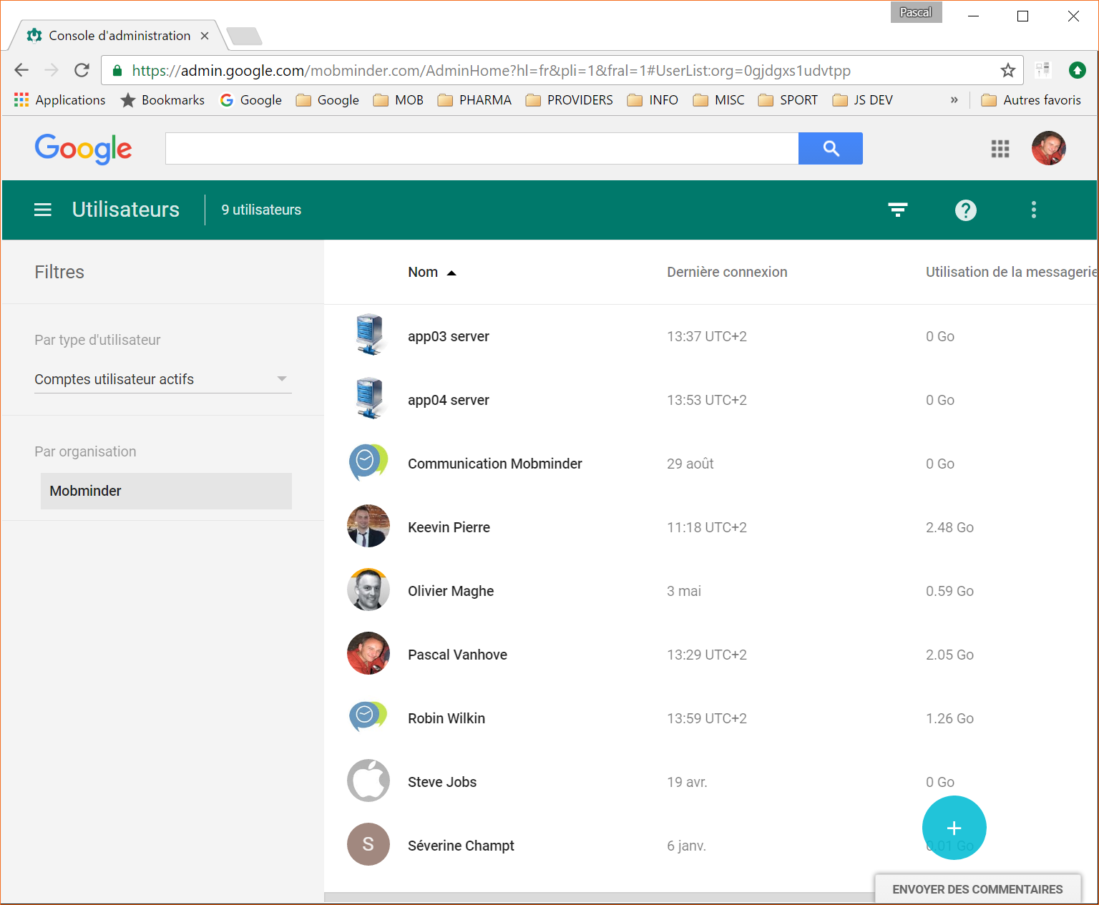

Summary dropbox:

Logs

Decisions about logs:

PHP

Modules:
Mobminder PHP code needs to run curl commands. So curl needs to be installed above PHP on both servers.

Ini file:

O Files of up to 9megs should be able to upload to the server.
O Mean time life a php session should be set to 24hours

Cron tasks

Decisions about crons:

We use separate files in the cron.d directory. Each file has a specific scope as per the destination of the jobs they launch:

- App crons
- PHP session purge cron
- Midnite dropbox task
- Hourly SQL backup cron
- Postfix summarize

- Il faudrait ici indiquer le chemin et le nom du fichier pour chaque groupe de cron

SSL encryption

Choosing a provider for SSL:

We have chosen RapidSSL

Testing SSL:

SSL must be tested
- on all subdomains
- from different web browsers: Chrome, Firefox, Safari, and MSIE.

Be carefull with subdomains, there are two vhost (one for http, and one for https )
Check the file /etc/apache2/sites-available/app0#.conf

Certificate instructions:

INSTALLATION INSTRUCTIONS

1. INSTALL CERTIFICATE:
Install the X.509 version of your certificate included at the end of this e-mail.
For installation instructions for your SSL Certificate, go to:
https://knowledge.rapidssl.com/support/ssl-certificate-support/index?page=content&id=SO16226

2. INTERMEDIATE CERTIFICATE ADVISORY:
You MUST install the RapidSSL intermediate Certificate on your server together with your Certificate or it may not operate correctly.

** MICROSOFT IIS and TOMCAT USERS
Microsoft and Tomcat users are advised to download a PKCS #7 formatted certificate from the GeoTrust User Portal:
https://products.geotrust.com/orders/orderinformation/authentication.do. PKCS #7 is the default format used by these vendors during installation and includes the intermediate CA certificate.

You can get your RapidSSL Intermediate Certificates at:
https://knowledge.rapidssl.com/support/ssl-certificate-support/index?page=content&id=AR1548

3. CHECK INSTALLATION:
Ensure you have installed your certificate correctly at:
https://knowledge.rapidssl.com/support/ssl-certificate-support/index?page=content&id=AR1549

4. INSTALL THE RAPIDSSL SITE SEAL:
Additionally, as part of your SSL Certificate Service, you are entitled to display the RapidSSL Site Seal - recognized across the Internet and around the world as a symbol of authenticity, security, and trust - to build consumer confidence in your Web site.

Installation instructions for the RapidSSL Site Seal can be found on the following link:
https://knowledge.rapidssl.com/support/ssl-certificate-support/index?page=content&id=SO14424&actp=LIST&viewlocale=en_US

If you require additional technical support please contact your Reseller.

Web Server CERTIFICATE

Setup and management of Users

Users can connect only using their SSH key. No standard server access is allowed.
Root mode is accessible using sudo su and entering your password.

login as: pascal
Authenticating with public key "rsa-key-20121112"
Linux app04.mobminder.com 3.14.32-xxxx-grs-ipv6-64 #7 SMP Wed Jan 27 18:05:09 CE T 2016 x86_64 GNU/Linux

server : 682694
ip : 178.33.228.75
hostname : app04.mobminder.com

pascal@app04:~$
pascal@app04:~$ sudo su

We trust you have received the usual lecture from the local System
Administrator. It usually boils down to these three things:

#1) Respect the privacy of others.
#2) Think before you type.
#3) With great power comes great responsibility.

[sudo] password for pascal:
root@app04:/home/pascal#

Tips about SSH connection:

Know who is connected on the server:

root@app04:/home/pascal# who
quentin pts/0 2016-09-19 11:11 (91.178.241.71)
pascal pts/1 2016-09-19 12:48 (91.178.241.71)
root@app04:/home/pascal#

Configure putty to connect using your SSH:

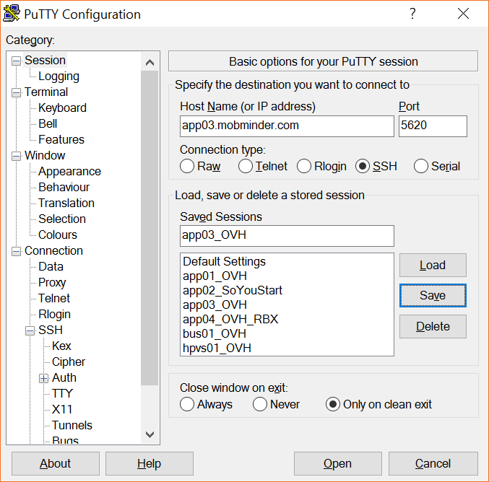

Mail server

A mail server should send postfix summarize reports to the webmaster.

Config file:

Updating the Mobminder baseline on the servers

Decisions about App updates:

Ici il faut expliquer la procedure pour mettre à jour le soft: notament l’utilisation du script ./pip.sh qui produit une copie instantanée vers /htdocs

Check list for setting up the tandem system

This section explains the chronological steps to be followed when a new server is installed :

O Linux Debian installé
O Raid soft opérationnel
O SSH clés installées (avec sudo su pour les users admins)
O Memoire allouée pour root suffisante?
O PHP installé ( !! ajouter le module curl, interface api http mBlox )
O Apache installé ( !! gestion des sous-domaines dans des dossiers aux cotés de /htdocs )
O MySQL master installé
O Crons installés (PHP5 sessions, Mob crons, Hourly backups, daily backups)
O MySQL slave installé
O IP failover installée
O SSL installé (Tester sur Chrome et Firefox - !! ouvrir le firewall)
O Firewall installé
O Dropbox installé
O Dossier /mobfiles copiés
O Sites-available dans /etc/apache2/ (reprendre la config des sous-domaines)
O Testing sur tous les sous-domaines
O Apache nombre d’utilisateurs simultanés augmenté (config)

Check list for testing the system

This section explains the chronological steps to be followed when a new server must be tested :

1/ Test the main domains and sub-domains. Include sub-domains needing parameters (agenda.mobminder.com , ical.mobminder.com, etc..
2/ Check that /mobfiles is filled up
3/ Check that every cron drops a log at given timeframe

Dedicated servers

June 2016, 2 dedicated servers have been booked. The provider is OVH.fr

App03.mobminder.com - Serveur no653114 @ 51.255.92.27 (Grave)

App04.mobminder.com - Serveur no682694 @ 178.33.228.75 (Roubaix)

IP failover : 5.196.168.140

URL routing

We use the DNS of Amazon. It is reachable via https://console.aws.amazon.com.
Login: pascal@mobminder.com
Service: route53

Choose DNS management
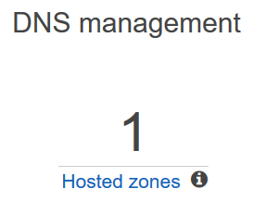

IP / server ip/names/location correspondence is like this:

app03.mobminder.com / 51.255.92.27 / OVH - Grave
app04.mobminder.com / 178.33.228.75 / OVH - Roubaix

IP failover procedure

In case of infrastructure failure, you can execute the following procedure. So the standby server takes over the app domain and the service can resume to customers.

- Connect to app04.mobminder.com (the non failed one, sudo root mandatory) :

Execute the script: /root/scripts/become-master.sh

This is a list of what this script makes
- SQL_front04 is released from the read-only state (PHP_04/apache can again write in the DB)
- SQL_front04 stops synchronizing from SQL_front03 (this operation lets SQL_front04 work in master mode)
- Reinitialize the sync operation to SQL_chrono04 (by making SQL_front a master, delta logs are starting from 0001 again)
- Add (remove) the ip interface in /etc/network/interfaces so we can answer the ip failover
- Writes 1 in globals Mobminder table field sendComm
- Creates a master.info file in /home (this file is used to e.g. prevent the Mobminder crons to run)

- Sur OVH client interface:

Go to Dedicated/IP(bottom left), click the gearwheel /move the IP failover/ choose the up server (ns30 or ns33).

- When the failed server is back: Connect to the failed server and make it the new slave

Execute the script: /root/scripts/become-slave.sh

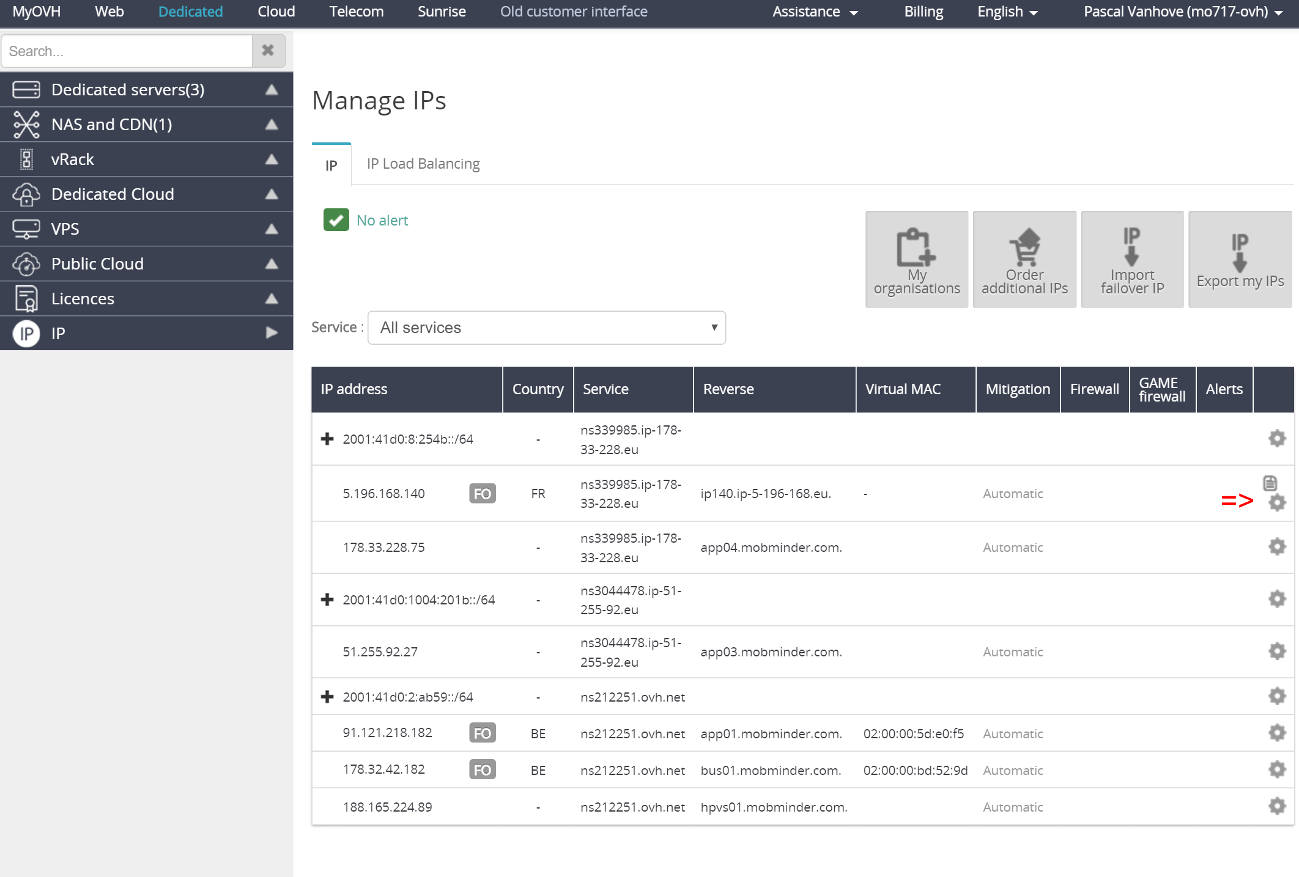

Tips about master/slave status:

When in master mode, the server has a specific file /home/master.info
Your prompt shows either STANDY or PRODUCTION so you know clearly what server you are on.

This prompt avatar is setup in the following script: /home/pascal/.bashrc

if [ -f /home/master.info ];then
PS1='\[\e[1;31m\][\u@\h \w]\e[1;37m\e[41m|PRODUCTION|\e[0m\e[0;31m\$\[\e[0m\] '
else
PS1='\[\e[1;12m\][\u@\h \w]\e[1;37m\e[44m|STANDBY|\e[0m\e[0;12m\$\[\e[0m\] '
fi

( this setup is proper to each user, it must be set in the bashrc of root and other users and this on each server )

Chronologic restore procedure

In case of data hacking, it might be necessary to restore a clean data situation as before the server was hacked. This procedure can NOT be executed on the standby server during standby operation, because it syncs from the master server.

Normaly, when your server data has been hacked or abused, the server itself is still running fine. IP failover is not mandatory before you restore a chronological backup.

You do this:

- Choose your backup

root@app04:/etc/mysql/backups#
root@app04:/etc/mysql/backups# ls -l
total 15389108
-rw-r--r-- 1 root root 350185683 Sep 17 17:01 2016-09-17:17:00-dump.zip
-rw-r--r-- 1 root root 350185683 Sep 17 18:01 2016-09-17:18:00-dump.zip
-rw-r--r-- 1 root root 350185683 Sep 17 19:01 2016-09-17:19:00-dump.zip
-rw-r--r-- 1 root root 350185683 Sep 17 20:01 2016-09-17:20:00-dump.zip
-rw-r--r-- 1 root root 350185682 Sep 17 21:01 2016-09-17:21:00-dump.zip
-rw-r--r-- 1 root root 350185683 Sep 17 22:01 2016-09-17:22:00-dump.zip
-rw-r--r-- 1 root root 350185682 Sep 17 23:01 2016-09-17:23:00-dump.zip
-rw-r--r-- 1 root root 350185683 Sep 18 00:01 2016-09-18:00:00-dump.zip
-rw-r--r-- 1 root root 350185683 Sep 18 01:01 2016-09-18:01:00-dump.zip
-rw-r--r-- 1 root root 350185683 Sep 18 02:01 2016-09-18:02:00-dump.zip
-rw-r--r-- 1 root root 350185683 Sep 18 03:01 2016-09-18:03:00-dump.zip
-rw-r--r-- 1 root root 350185683 Sep 18 04:01 2016-09-18:04:00-dump.zip
-rw-r--r-- 1 root root 350185683 Sep 18 05:01 2016-09-18:05:00-dump.zip
-rw-r--r-- 1 root root 350185683 Sep 18 06:01 2016-09-18:06:00-dump.zip
Double tab shows alternatives during completion service
- Execute the restore chronological command:

root@app04:/etc/mysql/backups# cd /root/scripts
root@app04:~/scripts#
root@app04:~/scripts# ls
amIMaster.sh become-master.sh become-slave.sh crons restoreChronological.sh
root@app04:~/scripts#
root@app04:~/scripts# sh restoreChronological.sh /etc/mysql/backups/2016-09-17\:
2016-09-17:17:00-dump.zip 2016-09-17:19:00-dump.zip 2016-09-17:21:00-dump.zip 2016-09-17:23:00-dump.zip
2016-09-17:18:00-dump.zip 2016-09-17:20:00-dump.zip 2016-09-17:22:00-dump.zip
root@app04:~/scripts# sh restoreChronological.sh /etc/mysql/backups/2016-09-17\:19\:00-dump.zip
Archive: /etc/mysql/backups/2016-09-17:19:00-dump.zip
inflating: /etc/mysql/backups/2016-09-17:19:00-dump.sql
file : /etc/mysql/backups/2016-09-17:19:00-dump.sql
Restoring DB with backup
database restored at state 2016-09-17:19:00-dump.zip
root@app04:~/scripts#
root@app04:~/scripts#

Inscription des alias serveur au moment où on se log :
/root/.bashrc

Par exemple,

# Note: PS1 and umask are already set in /etc/profile. You should not
# need this unless you want different defaults for root.
# PS1='${debian_chroot:+($debian_chroot)}\h:\w\$ '
# umask 022
if [ -f /home/master.info ];then
PS1='\[\e[1;31m\][\u@\h \w]\e[1;37m\e[41m|PRODUCTION|\e[0m\e[0;31m\$\[\e[0m\] '
else
PS1='\[\e[1;12m\][\u@\h \w]\e[1;37m\e[44m|STANDBY|\e[0m\e[0;12m\$\[\e[0m\] '
fi
# You may uncomment the following lines if you want `ls' to be colorized:
# export LS_OPTIONS='--color=auto'
# eval "`dircolors`"
# alias ls='ls $LS_OPTIONS'
# alias ll='ls $LS_OPTIONS -l'
# alias l='ls $LS_OPTIONS -lA'
#
# Some more alias to avoid making mistakes:
# alias rm='rm -i'
# alias cp='cp -i'
# alias mv='mv -i'
#VERY USEFUL : du -h / | sort -h
PATH=$PATH:~/.composer/vendor/bin
alias mm='mysqld_multi'
alias mysql0='mysql'
alias mysql1='mysql -u root -p --socket=/var/run/mysqld/mysqld1.sock'
#alias mysql1='mysql --socket=/var/run/mysqld/mysqld1.sock'
alias logmysql='tail -f /var/log/mysql/error.log'
alias logmysql1='tail -f /var/log/mysql1/error.log'

Résolution de problème - App03 Slave est en panne – (Mai 2020)

Il y a une procédure simplifiée dans le fichier 2021 – procédure de réalignement master-slave.
Dans cette procédure, le backup du master contient toutes les DB ainsi que le pointeur master. Lors du rechargement, le slave connaît la position pointeur et est prêt à démarrer.

  - Diagnostique :

# logmysql
# logmysql1

  - Procédure :
- Éteindre le mysql slave
- Couper la réplication du master (il ne suit plus la prod dès ce moment)
- Faire un backup du master
- Recharger ce backup sur le slave
- Identifier la position du master
- Relancer la réplication de master sur slave
- Relancer la réplication de prod sur master

Se connecter au prompt mysql :
# mysql
mysql> stop slave; -- (arrête son comportement de slave)
mysql> start slave; -- (ce qu’on fera après avoir réparé le mysql1)
mysql> exit
Bye
[root@app03 /home/pascal]|STANDBY|#

Trouver le password du slave :
# cat /etc/mysql/my.cnf | grep password

# It has been reported that passwords should be enclosed with ticks/quotes
password=Jf7v9R>%

Se connecter au prompt mysql :
# mysql1
# enter password :
#

Aller chercher la commande qui permet de faire un dump du master :
# cat /etc/cron.d/services

#Postfix summarize
59 23 * * * root sh /root/scripts/crons/mailReport.sh

#Backup database every hour
0 * * * * root sh /root/scripts/crons/backup-database.sh >> /var/log/mysqlbackup.log 2>&1

#Erase 3days+ backups every 1:2 AM. The directory should stay at a size of 35GB every 1AM
2 1 * * * root sh /root/scripts/crons/erase-old-backups.sh >> /var/log/mysqlbackup.log 2>&1

#Uploading database physically to dropBox every 2AM
0 2 * * * root sh /root/scripts/crons/backup-database-toDropBox.sh >> /var/log/mysqlbackup.log 2>&1

#Every month, delete old logs
0 0 1 * 0 root sh /root/scripts/crons/eraseOldLogs.sh

# cat /root/scripts/crons/backup-database.sh
#!/bin/sh
#This script is made to be run on SLAVE1 and SLAVE2 ONLY !!

TIME=$(date +%Y-%m-%d_%H:%M);
PATH2="/etc/mysql/backups/"
PATHFORBU="/etc/mysql/backups/$TIME-dump.sql";

#Connecting to SLAVE1, stop slave replication process, and dump
echo "$TIME : backing up database"
mysqladmin stop-slave --socket=/var/run/mysqld/mysqld1.sock
if [ $? -ne 0 ]; then #If couldn't stop slave process
echo "Error while stopping slave process"
exit 1;
fi
mysqldump --databases mobminder --socket=/var/run/mysqld/mysqld1.sock > $PATHFORBU
if [ $? -ne 0 ]; then #If error while backing up
echo "error while backing up"
exit 1;
fi

mysqladmin start-slave --socket=/var/run/mysqld/mysqld1.sock
if [ $? -ne 0 ]; then
echo "problem while restarting slave process";
exit 1;
fi
#This requires ZIP packet
cd $PATH2
zip $TIME-dump.zip $TIME-dump.sql
if [ $? -ne 0 ]; then
echo "problem while restarting slave process";
exit 1;
fi
rm $TIME-dump.sql

echo "$TIME : database backed up, file available at $PATH2"
#echo "use mobminder; FLUSH TABLES WITH READ LOCK;" | mysql

#Recording master status
#logFile=$(mysql -e "show master status" -s | tail -n 1 | awk {'print $1'})
#logPos=$(mysql -e "show master status" -s | tail -n 1 | awk {'print $2'})

On va faire le backup du master :

# mysqldump --databases mobminder --socket=/var/run/mysqld/mysqld.sock > /root/fixback_mob.sql -- (on a remplacé mysqld1 par mysqld et on redirige le backup vers /root/fixbackup.sql )
# mysqldump --databases smsgateaway --socket=/var/run/mysqld/mysqld.sock > /root/fixback_sms.sql

# ls -al /root/fixback*.sql
-rw-r--r-- 1 root root 8112809765 May 3 14:44 /root/fixbackup.sql

# cd /root // Il faut se déplacer dans le dossier où se trouve le backup !

# mysql1
Mysql> drop database mobminder; -- this takes like 4 minutes
Mysql> drop database smsgateaway; -- this takes like 5 seconds
Mysql> show databases;
+--------------------+
| Database |
+--------------------+
| information_schema |
| mysql |
| newmobcom |
| performance_schema |
| sys |
+--------------------+
6 rows in set (0.00 sec)
>mysql exit

# mysql1 < fixback_mob.sql; -- n’affiche pas de log, et il vaut mieux sinon ça prend des heures. (ça prend une dizaine de minutes)
# mysql1 < fixback_sms.sql; -- n’affiche pas de log, et il vaut mieux sinon ça prend des heures. (ça prend une dizaine de minutes)

  - Retrouver la position de Mysql Master (le slave doit démarrer là)

# mysql

mysql> show master status;
+------------------+----------+--------------+------------------+-------------------+
| File | Position | Binlog_Do_DB | Binlog_Ignore_DB | Executed_Gtid_Set |
+------------------+----------+--------------+------------------+-------------------+
| mysql-bin.005110 | 57999096 | | | |
+------------------+----------+--------------+------------------+-------------------+
1 row in set (0.00 sec)

- Pour faire la replication, le slave a besoin d’un username / password pour se connecter sur le master.

# CHANGE MASTER TO MASTER_HOST='127.0.0.1',MASTER_USER='slave1',MASTER_PASSWORD='slavepass',MASTER_LOG_FILE='mysql-bin.005110',MASTER_LOG_POS=57999096;

CHANGE MASTER TO MASTER_HOST='127.0.0.1',MASTER_USER='slave1',MASTER_PASSWORD='slavepass',MASTER_LOG_FILE='mysql-bin.005556',MASTER_LOG_POS=101340487;

Mais on a oublié le password pour le user slave avec les droits de replication:

# set password for 'slave1'@'localhost' = password('slavepass');
# flush privileges

(dans une autre fenêtre)
# logmysql1

(dans une autre fenêtre) (il y aura une erreur de ALTER USER sur le slave si on a change le password et que la replication était déjà en route)
# logmysql

# show master status;
+------------------+----------+--------------+------------------+-------------------+
| File | Position | Binlog_Do_DB | Binlog_Ignore_DB | Executed_Gtid_Set |
+------------------+----------+--------------+------------------+-------------------+
| mysql-bin.005110 | 57999494 | | | |
+------------------+----------+--------------+------------------+-------------------+
1 row in set (0.01 sec)

Mysql> use mobminder
Reading table information for completion of table and column names
You can turn off this feature to get a quicker startup with -A

Database changed
mysql> select count(*) from reservations;
+----------+
| count(*) |
+----------+
| 487130 |
+----------+
1 row in set (0.00 sec)

Mysql1> use mobminder
Reading table information for completion of table and column names
You can turn off this feature to get a quicker startup with -A

Database changed
Mysql1> select count(*) from reservations;
+----------+
| count(*) |
+----------+
| 487130 |
+----------+
1 row in set (0.00 sec)

#mysql1

mysql> stop slave;
Query OK, 0 rows affected (0.00 sec)

mysql> CHANGE MASTER TO MASTER_HOST='127.0.0.1',MASTER_USER='slave1',MASTER_PASSWORD='slavepass',MASTER_LOG_FILE='mysql-bin.005110',MASTER_LOG_POS=57999494;
Query OK, 0 rows affected, 2 warnings (0.01 sec)

mysql> start slave;
Query OK, 0 rows affected (0.00 sec)

# mysql

mysql> start slave; // démarre le comportement en mode slave: recopie les instructions de son master

Résolution de problème - App03 Master – la DB smsgateaway n’est pas synchrone

ATTENTION : Ca demande de couper la prod pendant un moment !

==On app03==
stop slave;
drop database mobminder;
drop database smsgateaway;
==Verifier qu'elles ont aussi disparu sur mysql1==

==On app04==
1 : Create new user for replication
CREATE USER 'app03'@'app03.mobminder.com' IDENTIFIED BY 'slavepass';
GRANT REPLICATION SLAVE ON *.* TO 'app03'@'app03.mobminder.com';

1.2 : service apache2 stop

2 : Stop table writing
#mysql
>mysql FLUSH TABLES WITH READ LOCK;

3 : Take master position
SHOW MASTER STATUS;

+------------------+----------+--------------+------------------+-------------------+
| File | Position | Binlog_Do_DB | Binlog_Ignore_DB | Executed_Gtid_Set |
+------------------+----------+--------------+------------------+-------------------+
| mysql-bin.006834 | 67780923 | | | |
+------------------+----------+--------------+------------------+-------------------+
1 row in set (0.00 sec)

4 : Dump databases
mysqldump --databases smsgateaway --socket=/var/run/mysqld/mysqld.sock > /root/smsgateawaybackup.sql
mysqldump --databases mobminder --socket=/var/run/mysqld/mysqld.sock > /root/mobminderbackup.sql

5 : Copy dump to app03

scp -P 5620 /root/smsgateawaybackup.sql root@app03.mobminder.com:/root/smsgateawaybackup.sql
scp -P 5620 /root/mobminderbackup.sql root@app03.mobminder.com:/root/mobminderbackup.sql
============

=======On app03 =========

6 : charger les dumps –- le rechargement de la DB Mobminder prends environ 15 min

cd /root
mysql < mobminderbackup.sql
mysql < smsgateawaybackup.sql

7 :
mysql1
show databases

8 : CHANGE MASTER TO MASTER_HOST='app04.mobminder.com',MASTER_USER='app03',MASTER_PASSWORD='slavepass',MASTER_LOG_FILE='mysql-bin.006834',MASTER_LOG_POS=67780923;

9 : set global sql_slave_skip_counter=1;

9 : start slave;
==Verifier log pour voir si la replication est OK (logmysql)==

==On app04==

9 : UNLOCK TABLES;
#A faire apres etre sur que la replication est opérationelle entre app03 et 04,
#car si elle n'est pas opérationelle, il faut peut etre créer un nouveau user / changer le password d'un user. si l'étape 1 a raté par exemple.

10 : service apache2 start

